BULLETIN FROM THE KOTLAS CONNECTION CHAIRS

Issue # 47 June 2016

A BUSY WEEK FOR OUR RUSSIAN GUESTS

After a chance to catch up on some sleep after their very late arrival at the Portland Jetport on March 16, this year’s invitees to Russian Sampler 2016, students Konstantin (Kostya) Epp and Daria (Dasha) Slepukhina with returning English-teacher Arina Pavlova, started their visit with a tour of Waterville on March 17. They had a guided tour of the renovated Waterville Opera House, followed by lunch at Jorgensen’s Café with Kim Lindlof, who explained her job at the Mid-Maine Chamber of Commerce and talked about the community programs undertaken by REM and Waterville Main Street. The group then went to City Hall and got Maine-themed gift baskets from Amanda Esler in the mayor’s office. Of course, no visit to Waterville would be complete without photo ops at the sister-city sign and the commemorative birch trees. Several Kotlas Connection members accompanied the guests for all or part of the day: Mary Coombs, Carl Daiker Mark Fisher, Herb Foster, Phil Gonyar, and Sheila McCarthy. In the afternoon, Sheila took the guests for a tour of Colby College, including coffee at the campus Spa with Russian majors. The evening concluded with a dessert reception for the Russians and Kotlas Connection members at the home of Carl and Phil, where eagerly awaited letters from our Russian friends were distributed.

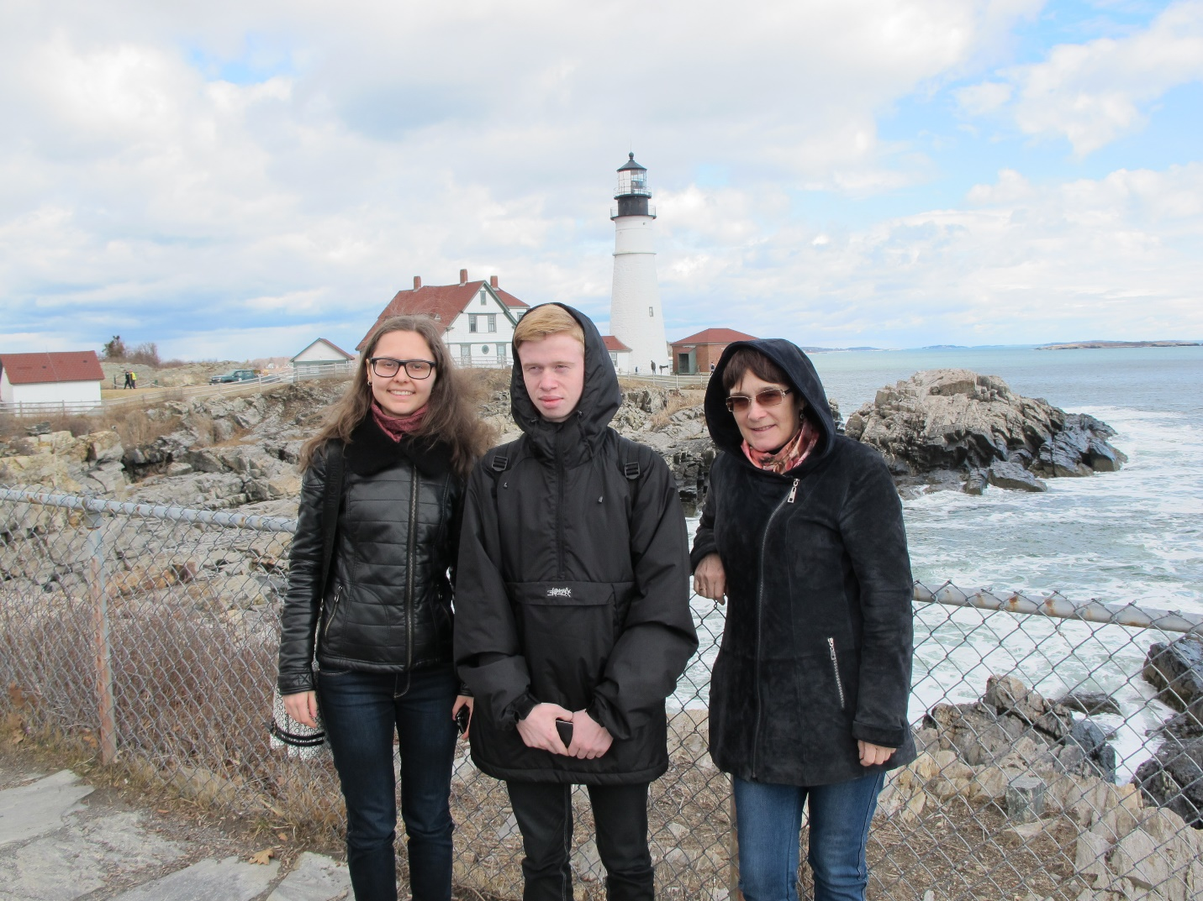
Seeing the ocean always seems to be one of the “must do” things on every Kotlas guest’s wish list. Our Russian Sampler guests were no exception. Phil and Carl made sure a trip to Portland Head Light was on their schedule for their second day. The weather on the day of the trip was beautiful. After photo stops, a chance to touch the Atlantic Ocean waters, and a stroll along the beach, our little party headed for more fun in downtown Portland. There our guests did some souvenir shopping, ate lobster rolls at DeMillo’s, and got a chance to walk around several of the blocks of the Old Port. En route back to Waterville, we made stops to see Eartha, the world’s largest globe, and the Freeport Indian statue.

Saturday was a free day to explore individual interests and activities with their host families: Herb and Nancy Foster (Arina), Sheila McCarthy and Cliff Reid (Kostya), and Mary and Earl Coombs (Dasha). The evening concluded with a blini and mushroom soup party at Mark’s home. Mark made the soup. His current guests Roman Blyzniuk, Alexander Shatscov, and Maksim Vaganov, and his foster son, Jonathan, were in charge of the blini. After many failed attempts at the blini, Alexander called his mother in Mariupol, Ukraine, and got a 45-minute step-by-step lesson in the art of blini-making. Governor Paul LePage attended the party for an hour, conversed with all the visitors, and sent his warm regards back to Mayor of Kotlas Andrei Bralnin and his other friends in Kotlas.

Sunday was also a free day with families and a time to make final preparations for Russian Sampler. Host families took them to church for Palm Sunday services.

On Monday, for the first time in the history of Russian Sampler, a snowstorm closed most of the participating schools and Sampler had to be cancelled. Needless to say, everyone was disappointed. In lieu of Sampler, Mary was able to arrange a visit to Winslow Junior High School, which had remained open. Dasha and Kostya gave their presentations on Russian schools and student activities that they would have done at Sampler. Arina talked briefly about family life through the seasons. The 7th- and 8th-graders enjoyed the presentations and learned a lot about the lives of Russian students. All the host families and guests were able to have dinner together that evening at Ming Lee’s restaurant in Waterville.

Tuesday was Augusta day. Committee members Ellen Corey, Mark, and Herb accompanied the guests to the Maine State House, where we were met by Secretary of State Matthew Dunlap. Mr. Dunlap was very generous with his time, giving us a tour, explaining the history of the building, and showing the Hall of Flags, the Senate and House of Representatives chambers, and the Rotunda. Our group was joined by Carl and Phil for a tour of the Maine State Museum. Phil served as our tour guide, and our guests were very interested in seeing the museum’s comprehensive presentation of life in Maine. No visit to Augusta is complete without a visit and photo op at the memorial statue to Samantha Smith, who, even after all these years, is loved by Russians. The evening concluded with our traditional Thanksgiving dinner—turkey and all the fixins—at the home of Pauline Mayhew.

On Wednesday, at the Albert S. Hall School in Waterville, Mary Dunn’s 5th-graders welcomed the Russians with a big sign, ДОБРО ПОЖАЛОВАТ! (WELCOME!) The Hall students presented a short strings concert, and then they made cute little Russian dolls with linen and yarn. The Russians had a lively and interesting tour of the school and had a great time seeing a typical American 5th-grade classroom. All three were impressed by how proud the children were of their school and by the many projects that decorated every inch of the school corridors. The next stop was Mount Merici Academy, where 8th-graders also had the opportunity to interview Dasha and Kostya about what Russian kids do after school and what rap groups are their favorites. Russia was not a country they had previously studied, but as a result of our visit, the class made a decision to create a study of Russian life as their final annual exhibition project. Following lunch with Sheila and Mary, Herb arranged a tour of Thomas College, where they were met by Nancy Charette, Executive Assistant in charge of Placement. They were given a one-hour tour by two student ambassadors, one of whom was from Sweden. Like previous delegations, all were impressed by the friendly atmosphere at Thomas, and the intimate feeling that one gets there. Highlights included a visit to the Hall of Flags and the Ken and Eva Green Memorial Library. The latter was especially meaningful for Arina, who had hosted Ken the last time he was in Kotlas. The evening ended with a pizza party at the home of Sheila and Cliff, where letters and small gifts were distributed for carrying to Kotlas.

On Thursday our Russian visitors met with 5th-, 6th- and 7th-grade students at St. John Catholic School in Winslow. Rachel Roberge’s students asked many interesting questions and exchanged ideas about family life in both countries. In the afternoon the guests visited Mid-Maine Technical Center, where they had a delicious lunch prepared by students in the Culinary Arts program, and got a first-hand view of EMT training sessions. When they donned the bulky, heavy firemen’s jackets, helmets, and oxygen tanks, they were so weighted down that they could scarcely move. They saw auto mechanics and very much enjoyed walking through the house currently being constructed by the Technical Center students. Arina, Dasha and Kostya finished up the day with a tour of the Harold and Bibby Alfond After School Program.

On Friday an almost unheard of second snow cancellation day in one week squelched plans for a student-shadowing day at Waterville and Winslow High Schools. Mary and Sheila took Arina and the students to Starbucks in the afternoon for a comprehensive debriefing session about their entire visit experience.

On Saturday Mary took our guests to Bacon Farm Maple Products in Sidney, where they saw the sugaring-off process and purchased maple-syrup products to take home. Sheila and Mary then transported them for an overnight in Portland so they could get to the Jetport for a really early flight on Sunday. They concluded their American days with a private tour of New York City.

DARIA SLEPUKHINA’S IMPRESSIONS

The entire trip to the State of Maine was a great and unforgettable event in my life. It was a very big experience for me. The friendly, hospitable and very nice people really impressed me. As for American schools, I was surprised that students don't wear uniforms, and also that they get a personal computer to use for studying. It was really exciting to talk with American students about Russian schools. And it was interesting to learn about the similarities and differences of life of American and Russian teenagers. And now I miss staying in Waterville and all the members of the Kotlas Committee.

GREAT RUSSIAN FILM SERIES CONTINUES

The Kotlas Connection is very pleased to announce that in Fall 2016, we will sponsor our fourth installment of Russian film viewing and discussion. From September-November 2016, we will be viewing a new Russian version of Boris Pasternak’s epic, Doctor Zhivago. This series was made for Russian television, and it is the first Russian studio production of Zhivago, a work which was banned for many years in the Soviet Union and the Russian Federation.

The film documents the life and times of a young doctor-poet, Yurii Zhivago, as he and his family live through the tumultuous last years of the Romanov Dynasty, the first revolution of 1905, the revolutions of 1917, and World War I. Just as Leo Tolstoi in War and Peace shows readers Russia before, during and after Napoleon’s invasion (1812), so too does Pasternak use ordinary characters and families during a time of unprecedented political and social upheaval in the early 20th century to paint his picture of another societal earthquake in Russia.

Film-goers will be able sign up for the film course through Mid-Maine Regional Adult Education when its course catalog for Fall 2016 becomes available.

POSSIBLE TRIP TO KOTLAS 2017

In June 2017, our sister city will have a gala 100th anniversary celebration of the founding of Kotlas. The Kotlas Connection has been invited to send a delegation to join the festivities. The day is usually scheduled in the first two weeks of June. If you are thinking about a trip to Kotlas, note the time frame on your calendars. As plans firm up, we will keep you up to date through the Chairs’ Bulletins.

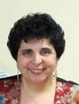
OUR REM AWARD RECIPIENT 2016

In recognition of her long service to the Kotlas-Waterville Area Sister City Connection, Martha Coury Patterson was our nominee for the annual REM Volunteer Awards. Martha has been active in the Kotlas Connection since 1999. She served as co-chair for four years and still participates in organizing and implementing visits of the various Kotlas delegations. She delights in teaching Russian cooking to students at our annual Russian Sampler.

Martha traveled to Kotlas as a good will ambassador in 2012 to celebrate the 95th anniversary of Kotlas and returned to Kotlas in 2015 to participate in the celebration of 25 years of the sister-city relationship. Later, Mayor Andrei Bralnin and members of his Duma came to Waterville to continue the celebration of people-to-people diplomacy. Martha and her husband, Neal, hosted several delegations that came from Kotlas at their home and at their camp and had the pleasure of hosting a student from the Kotlas area when their children were in high school.

