BULLETIN FROM THE KOTLAS
CONNECTION CHAIRS
Issue #41 August, 2013

KEN GREEN MEMORIUM

It is with great sadness that we announce the death of our co-chair, Ken Green. Ken passed away on June 23rd at home surrounded by his wife Eva and sons Anders, Henrik, and Max.

Ken returned from Russia at the end of February complaining of numbness in his right arm. Tests eventually showed a malignant brain tumor to be the cause. He underwent treatment, but it was ineffective. Ken suffered a stroke on the 21st and died two nights later. He was 75.

Ken became involved with the Kotlas Connection in 2006. That was the year the Connection conceived the idea of bringing a group of medical professionals from Kotlas to visit Waterville-area hospitals. Ken had taught conversational English in the public schools of Izhevsk, Russia for a month in each of the preceding three years. Because of his interest in Russia, and his position of a local retired doctor, Ken was asked to help raise funds and plan a program for the visiting doctors. He accepted his challenge with enthusiasm. Ken, and his wife Eva, hosted Dr. Alexandre Menshakov of the Kotlas Diagnostic Clinic, and the two, became good friends despite the challenge of conversing in their common language, German. When the delegation left, he continued his involvement in the Connection, and eventually joined the executive committee. He returned to Russia three more times to teach, but always to the Archangel Oblast.

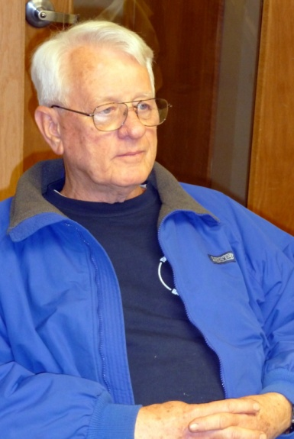 Ken felt deeply that one of the goals of the Kotlas Connection should be to foster an exchange of college students between Waterville and Kotlas/Archangel. In 2008 he approached Thomas College with that idea, and the next year the first post-graduate student from Kotlas came to Thomas to study for a year. She was followed by two teachers who each spent a semester teaching and studying here.
Figure 1 - Ken Green - 2009

In July of 2012, as a result of an initiative begun by Neale Duffett and the Archangel Committee in Portland, five leaders from the International Institute of Management (IIM), a business school in Archangel, had visited Portland and Portsmouth, NH seeking some kind of relationship with a US college. On his most recent trip to Archangel, Ken had a meeting with Viktoria Podolskaya, a representative of the IIM. Naturally, Ken, in his role as unofficial ambassador made a strong case for Thomas College. In April of this year, IIM and Thomas had a SKYPE session, and this coming November, 2013, Viktoria will visit Maine. Long-range plans include a projected visit to Archangel next year by Thomas College Provost Tom Edwards to further promote this relationship. We feel Ken would be very pleased to know that his meeting in Archangel could eventually lead to an exchange that he long dreamed about.

The following is a testimonial to Ken by Bob Moore, Vice President of Advancement at Thomas College:

Dr. Kenneth Green was a huge supporter of Thomas College and its students. Because of his passion for Waterville’s sister city Kotlas, Russia in 2008 he inaugurated a scholarship fund to allow students and teachers from Kotlas to attend Thomas College for a full semester. His goal was to increase diversity of the Educational programs at Thomas. In 2011, Dr. Green’s association with the College further expanded through the inception of the Thomas College Longfellow Scholarship for International Students. Dr. Green was recently awarded an Honorary Degree, Doctor of Humane Letters, at the College’s 119th Commencement Ceremony in May. His support, and the opportunities he provided for Thomas students, is immeasurable.

Following is a letter of condolence to Eva from the Waterville Committee in Kotlas:

Dear Eva – We are deeply saddened by Ken’s death. He was a marvelous person and amazed many by his generosity and good will. We miss him terribly, and we realize what an awful shock his passing has been for you.

We remember and will never forget how much joy he found in every opportunity to organize meetings between Russians and Americans, both in the United States and in Russia. Thanks to his efforts, the contacts between the citizens of our two cities have become better and stronger.

Ken was blessed with a wondrous ability to converse with children when he worked in our schools; he could get English conversations going with young pupils as easily as with the older pupils, and with both these age groups he devised topics of interest for every pupil. The children of Kotlas, who studied with him in conversation courses at the Lyceum, have the most touching memories of his classes, which they found both comprehensible and exciting.

Ken was our dearest friend. We are proud to have known him.

The Waterville Committee of the City of Kotlas
2 July 2013

Editor’s note: This “reporter” has recently visited Eva at home, and is happy to pass along word that she is doing well. She uses words like “coping”, and “sorting out”, but it is obvious that she has an established routine which keeps her very busy. Her son Henrik helps her with heavier chores, and she is training Alex to become a therapy dog at nursing homes and hospitals.

A TREE GROWS IN KOTLAS

After nearly three weeks in the Baltic countries (Lithuania, Latvia, and Estonia) and Kiev, Ukraine our tour arrived in St. Petersburg. This stop marked the end of the tour. However, our tour company, OAT (Overseas Adventure Travel) allows travelers to extend independently and continue their experience. We decided to take advantage of this opportunity to go on to Kotlas.

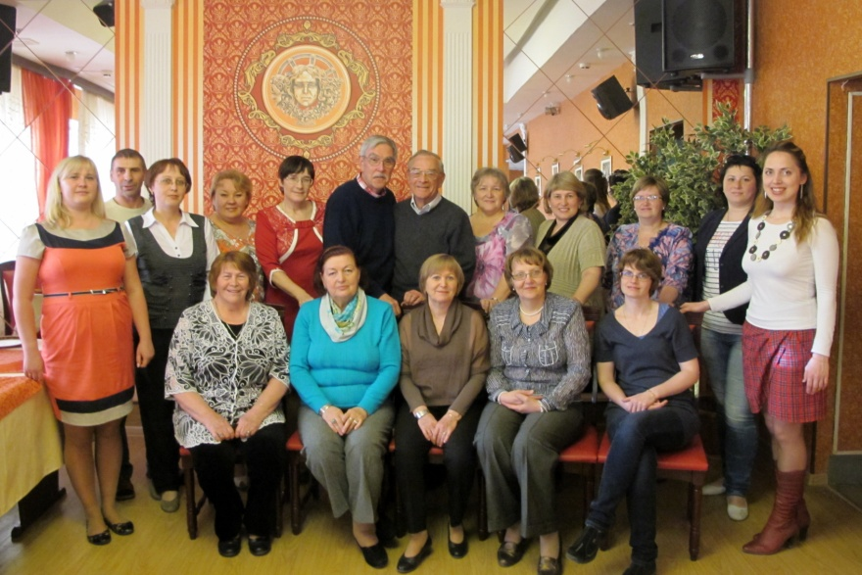We made arrangements with Marina Abakumova (years earlier she spent a school year living with the Pattersons) to buy train tickets for us to Kotlas. Before we arrived she and her significant other took jobs in Sochi which is preparing to host the Winter Olympics. She turned the train tickets over to Anya
Figure 2 - Waterville Committee Dinner

Egorova (she spent a school year in Winslow living with the Coombs and is the daughter of Z. I. Egorova from the first Kotlas delegation to Waterville). On June 26th, tickets in hand, we boarded the train for the nearly 24-hour train ride to Kotlas. We shared a compartment with two young men returning to their jobs at the paper mill in Koryazhma (east of Kotlas).

Arriving in Kotlas we were met by Arina Pavlova (a member of the 20th Anniversary delegation and other visits to Waterville) who was our hostess for our stay. After breakfast and a quick shower we were off for a tour of the Kotlas Rehabilitation Center for Children with Special Needs, a new concept for the Kotlas area. There we met Olga Maltseva and Anna Semina at their jobs. They had both been in Waterville earlier in the year as part of the Open World Social Services delegation. Later in the day we would see the other Social Services delegation members (Svetlana Kapustina, Galena Ivanova, and Alexsei Subbotin) at a dinner hosted by the Waterville Committee. Greetings were exchanged. Since our visit was informal no official business was discussed.

We started our next day with a visit to the Pedagogical College. Tanya Shelygina was our hostess. Tanya spent a semester in Waterville teaching and studying at Thomas College. We were joined on the tour by the director of the school. Final exams were in progress, so we had an opportunity to observe their exam process. While there we again met Alexsei Subbotin who teaches there. We spent a class period with students of Tanya and Pavel Koptelov (who had also spent a semester at Thomas College) trying to get them to use their limited English. After a delicious tea break with senior staff including Olga Popova (a member of the 2008 teacher delegation to Waterville) we left for a visit with Anna Abakumova (mother of Sochi-bound Marina). Later in the afternoon we met with Nikolai Sheptakov and his family. Nikolai was another of the members of the first delegation from Kotlas to Waterville.

Late that afternoon we were guests at a meeting of non-profit groups of Kotlas. A first for them, the meeting was organized by the Waterville Committee. Members of the Waterville Committee had attended a similar REM partners meeting while visiting in Waterville and thought it was an idea they could adopt. Among those attending were representatives of several ethnic groups, the museum, the library, the veterans, and the Red Cross. That evening we were entertained at a local Azerbaijani restaurant at a dinner with representatives of the city administration including Deputy Mayor Eduard Avilkin (he had been to Waterville in 2010 as a member of the sister city 20th anniversary celebration), members of the Waterville Committee, and our Azerbaijani hosts.

Our third day began at Lyceum #3 for an end-of-the-school year tree-planting ceremony. We assisted the students (all formally dressed for the occasion) in planting over 50 trees on the river bank behind the school. Later that day Zina Egorova, her husband Leonid, and Yulia Sorokina (who was the teacher guest at the 2009 Russian Sampler) took us to Veliky Ustyug to see several of the historic churches and to buy more supplies for our annual Christmas ornament sale. That evening we attended the awards assembly for Lyceum #3 held at the House of Culture. We finished the day with a visit and dinner with Vycheslav Chernyk and his wife Galena. Slava was a third member of that first delegation from Kotlas to Waterville.

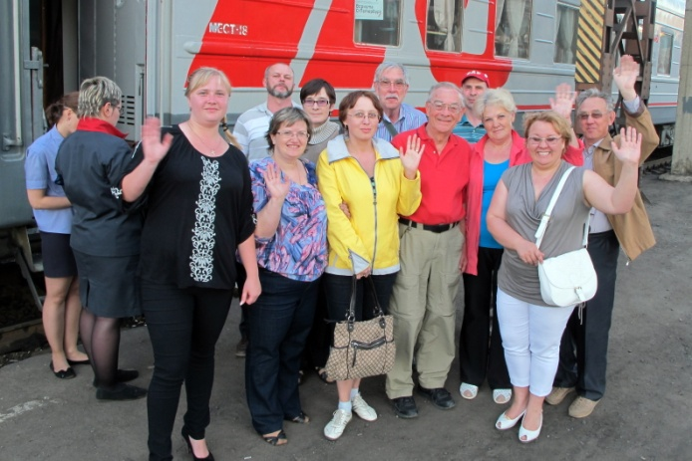Our fourth and final day in Kotlas began with a visit with Inna Tushina, a long-time member of the Waterville Committee and several time visitor to Waterville. We toured the new home her husband Yuri and their sons are building. We had lunch with the Minins, parents of a recent student guest of Mark Fisher. They live in one of the new Palkin-built apartments. Later that afternoon we were hosted for tea by Zina Egorova and Lyuba Zinovkina, another Waterville visitor and long-time member of the Waterville Committee. It was then time to pack, have a final visit with our hostess Arina, and board the train for our return to St. Petersburg. On the return trip we traveled first class (the way to go) in a private and very comfortable compartment. After an overnight in St. Petersburg we returned to Waterville on June 1st.
Figure 3 - Departure from Kotlas

Phil Gonyar and Carl Daiker

OPEN WORLD SOCIAL SERVICES WORKERS’ DELEGATION ARRIVES

The Kotlas-Waterville Area Sister City Connection happily welcomed five social service workers from the Kotlas area and their interpreter- facilitator on Friday, April 12, 2013. For the third time, the Open World Leadership Center approved a Connection application to host a professional delegation; in the past it’s been business/municipal leaders and teachers, and this year the Open World focus is on social services. After a two-day orientation session in Washington, D.C., the Russian guests arrived in Portland to flowers and smiles of greeting. And so began eight days of non-stop professional meetings, roundtable discussions with peers, and tours of facilities in Central Maine.

Bright and early on Saturday morning, the Russians were “invigorated” with a very chilly walk on Main Street and browsed some of the downtown Waterville stores. At the Kotlas-Waterville Area Sister City sign, the delegates stopped for photos. Delegation members were Olga Mal’tseva, Educational Psychologist and Director of Child Development Services, Kotlas Rehabilitation Center for Children with Special Needs; Anna Semina, Physical Therapist, Kotlas Rehabilitation Center for Children with Special Needs; Galina Ivanova, Deputy Executive Director, Kotlas Special Services Center; Svetlana Kapustina, Social Worker, Assistant Principal for Occupational Health, School #3; Aleksei Subbotin, Instructor in Social Work, Kotlas Vocational School of Education; Facilitator/Interpreter Evgeniia Leonovich, Associate Professor, Pyatigorsk State Linguistics University.

After lunch with abundant coffee, tea, and hot chocolate, the group went to Augusta to tour the Maine State Museum with Connection members and host families. The families took the delegates on short shopping trips, then to their homes for a short rest before the Welcoming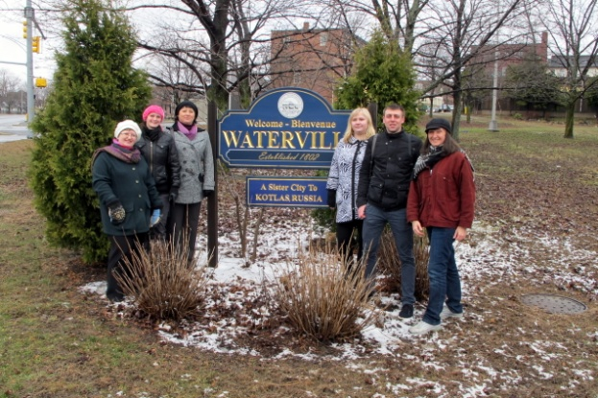 Dinner at the home of Marilyn Hall, Executive Committee Member. Ellen Corey, Executive Committee Member and chief organizer of the Open World visit, welcomed the guests, presented them with Open World briefcases and reviewed the schedule for the week’s visits. The delegates presented an array of Russian gifts and souvenirs to the Kotlas Committee.
Figure 4 - l to r: Olga Maltseva, Anna Semina Galena Ivanova, Svetlana Kapustina, Aleksey Subbotin, and Yevgenia Leonovich (facilitator)

On Sunday morning, our member tour guides extraordinaire, Carl Daiker and Phil Gonyar, took the delegates off on a trip to Acadia National Park to put their toes into the freezing waters of the Atlantic at Sand Beach. Their first-ever lobster rolls consumed, the travelers returned to their host families and prepared for Monday, their first “work” day.

Monday morning began with a breakfast reception at the offices of Karen Heck, Mayor of Waterville. Mayor Heck outlined area social services -- municipal, state, and federal – and answered a volley of questions from the delegates. She also presented the delegates with gifts from the City of Waterville.

For the rest of the day, the delegates went on a tour of High Hopes Clubhouse and had lunch with Club members. Pauline and Jack Mayhew led visits to Hospice Volunteers of Waterville offices and Mid-Maine Homeless Shelter. The delegates spoke again and again about the passion of the staff at all the facilities and were amazed by the activities performed by volunteers from the community. Volunteerism, they said, is only in its very first stages at home, and they wish that someday it will equal the community participation they saw throughout the week in Maine.

On Tuesday, they toured Educare with Herb Foster and had lunch with Mary Coombs and a school psychologist; visited the Maine Center for Integrated Rehabilitation; and ended the day with a discussion with Women, Infants, and Children (WIC) staff members. In the evening, Martha Patterson, Committee Co-Chair, hosted dinner at her home, and the guests were presented with gift bags from the Kotlas Committee.

Wednesday morning’s visit to Care and Comfort focused on home care specialties, with a concluding discussion of funding, a keenly interesting topic for the delegates. The fact that one of the psychologists at Care and Comfort is a Russian speaker from Moldova made the morning even more fruitful for the group. Wednesday’s visit to the State House began with a greeting from State Senator Colleen Lachowicz, a social worker, who introduced the group to pending legislation in the area of social services.

Senator Lachowicz hosted lunch for the delegates at the State House cafeteria. During the State House tour, the Russians took possession of the podium with much pomp and circumstance.

Later in the day, Governor Paul Le Page, who has visited Kotlas twice in recent years, welcomed the guests warmly, presented them with gift bags, and talked with them both about state government and about his fond memories of his trips to Kotlas.

Thursday’s schedule, led by Mark Fisher, included visits and discussion at Becket House, the Kennebec County Jail, and the Behavioral Health Access Center. Prior to dinner, the delegates sat for interviews with local reporters, recapping their impressions of the week.

At the community dinner, “Thanksgiving in April,” hosted by Phil Gonyar and Carl Daiker, catered by REM at the Forum, the delegates were greeted by an enthusiastic group of about 60 community members and social service workers, who had come to hear the delegates’ presentations about their work places at home in Kotlas. The scheduled question and answer session ended, but the conversations went on in informal groupings for the remainder of the friendly and productive evening. “We learned a lot from each other,” remarked one Waterville guest.

The delegation’s final day was as jam-packed as all the other days of the visit. Delegates began with a tour and meetings at the Alfond Youth Center; they had lunch at the Sacred Heart Soup Kitchen, talking with Director Richard Willette, staff members, and diners; Mount Saint Joseph Residence and Rehabilitation staff discussed long-term care with the Russian guests; they ended the day at the Edmund N. Ervin Pediatric Center, where staff members showed them the facility and demonstrated some of the therapy equipment.

Their final evening was an informal pizza party, at which both the Russians and the Americans delivered many fond farewells. It had been a very busy week for these young, endlessly energetic professionals, full to the brim with new impressions and intense business discussions with their American peers. Exhilarated and weary, they returned to their host families to the task of packing up their bulging suitcases and more fond farewell moments. It was a memorable week for all the participants, both Russian and American, and everyone hopes that these initial contacts will continue and bring future fruitful exchange opportunities.

Счастливого пути! to our friends Anna, Evgeniia, Aleksei, Galina, Ol’ga, and Svetlana!

War and Peace: Two Film Interpretations of Leo Tolstoy’s Epic Novel

The Kotlas-Waterville Area Sister City Connection is pleased to announce that we will offer a third Russian film course with the Mid-Maine Regional Adult Education program during the fall semester 2013. We hope that you, your family, and your friends will join this group for film viewing and discussion and our traditional concluding Russian dinner.

This year we’ve chosen Leo Tolstoy’s epic novel, War and Peace, as our film topic. We’ll watch the 1968 masterpiece Russian film version of the novel, with acclaimed actor and director Sergei Bondarchuk, and the Warner Brothers 1956 film, starring Audrey Hepburn, Henry Fonda, and Mel Ferrer.

In War and Peace, Tolstoy examines early 19th century Russia, before, during, and after Napoleon’s 1812 invasion of Russia. The novel – and both film versions – contrast the military strategy and tragedies of war with Tolstoy’s incisive societal portrait of everyday Russia, seen through the eyes of three aristocratic Russian families. The cast of characters is vast, including Tolstoy’s scathing portrait of Napoleon Bonaparte, his tender depiction of the young Tsar Alexander I, and his loving tribute to Mikhail Kutuzov, the Russian Commander-General of the woeful Russian army. In addition to these historical personages, Tolstoy fills his novel with a portrait gallery of Russians, none so beloved to all Russians as his errant philosopher Count Pierre Bezukhov; the handsome, noble, and ill-fated Prince Andrei Bolkonsky; and the sylphlike ideal of Russian womanhood, Natasha Rostova.

Both films are classics of their time, well worthy of enjoyable viewing and lively discussion, as we compare and contrast the two directors’ interpretations of the novel.

We hope that you will join our Tuesday evening course, 6:00-8:30 p.m., beginning on September 24th and concluding on November 19th with a home cooked Russian dinner. To register for the course, please call Mid-Maine Regional Adult Education at 873-5754 or on-line at adulted@fc.wtvl.k12.me.us.

20th RUSSIAN SAMPLER ANOTHER BIG SUCCESS

On Monday, March 25, junior and senior high school students from around the Waterville area gathered at Colby College for our 20th annual Russian Sampler. This year’s invited guests from Kotlas were Valentina Maklakova, a teacher of English in Privodino; Artem Starostenko, a 17-year old 11th grade student in Vychegodsky; and Victoria Bolshakova, a 15-year old 10th grade student at School #2 in Kotlas. For more details about this year’s Sampler please see the Kotlas Connection website (www.Kotlas.org).

MARK YOUR CALENDAR

There are two events coming in November that should not be missed.

- The Annual Meeting of the Kotlas Connection will take place on Wednesday, November 13th at 7 PM at the Forum in the Center in downtown Waterville. As always, there will be lots of goodies, camaraderie, and reminiscing. Please consider joining us. More information about the program for the meeting will be forthcoming.

- As many of you know the ties between Portland and its sister city of Archangel go back to the early 1940s. Most World War II shipping convoys to Russia formed in Portland’s Casco Bay before leaving for the ports of Murmansk and Archangel. They brought much needed food, fuel, medical supplies, and ammunition to the hard-pressed Russian people. Portland and Archangel formed a sister city connection in 1988 several years before Waterville and Kotlas. On November 18th of this year Portland will celebrate the 25th anniversary of the signing of the “treaty on friendly ties” with an official commemoration, and the members of the Kotlas Connection are invited. The celebration will be held at the Westbrook Middle School Cafeteria, 471 Stroudwater Street, Westbrook, ME beginning at 4 PM. Interested parties should make their intentions known by calling Herb Foster at 872-5217 to arrange car-pooling for the day.

WANT TO KNOW MORE?

For more information on the Connection’s activities, please visit our web site at http://www.kotlas.org.

