BULLETIN FROM THE KOTLAS
CONNECTION CHAIRS
Issue #43 October, 2014

ANNUAL MEETING

The annual meeting of the Connection will take place on Wednesday, November 19th at 7 PM at the Forum in the Center in downtown Waterville. As always, there will be lots of goodies, camaraderie, and reminiscing. There will be a brief presentation by members of the Connection on Russian history and culture. Please consider joining us. Elections will be held for Secretary and Executive Committee members. Martha Patterson is in the middle of her 2-year term as Chair and Carl Daiker is in the middle of his 2-year term as Treasurer. Sheila McCarthy has agreed to run for re-election as Secretary. Executive Committee members up for re-election are Mary Coombs, Ellen Corey, Joe Couture, John Engle, Mark Fisher, Herb Foster, Marilyn Hall, and Pauline Mayhew. If you are interested in serving on the Executive Committee or participating in any aspect of the Connection’s activities, please contact Chair Martha Patterson (207-872-5935).

CHRISTMAS ORNAMENT SALES

The Connection is looking forward to its annual Christmas ornament sales. Ornaments will be sold in Waterville at the Washington St. branch of KFS (Kennebec Federal Savings) and at Jorgensen’s Café, 103 Main Street, Waterville starting the day after Thanksgiving. Ornaments will also be sold at the Temple Academy Craft Fair on Saturday, December 6th from 9 AM to 2 PM and at the Holiday Craft Fair at Waterville Senior High School on December 13th from 9 am to 2:30 pm. Other venues may be added. Some exciting new ornaments have been added this year. Come early for the best selection.

RUSSIAN SAMPLER 2014
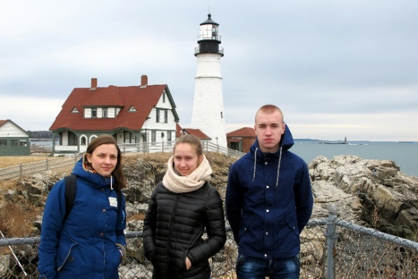
The 21st annual Russian Sampler was held at Colby College on Monday, March 24th. The Connection was pleased to welcome English teacher Anna Lobanova and two high school students, Anna Milianina and Danil Osminin. During their 10-day visit to the Waterville area our Russian guests participated in a number of Connection-sponsored activities and sightseeing.
Figure 1: Teacher Anna Lobanova with students Anna Milianina and Danil Osminin at Portland Head Light

At the Sampler teacher Anna Lobanova made a presentation to the students about life in a Russian dacha (similar to our lake camps). Anna Milianina spoke about Russian schools, and Danil concentrated on talking about Russian sports.

The visit included a welcoming dessert reception, a tour of the City of Waterville, a traditional pot luck supper, a trip to Portland Head Light, participation in the Russian Sampler, a presentation before the Mid-Maine Global Forum, and school visits to Winslow, Messalonskee, and Waterville. Their visit to the US culminated with a post-Waterville visit to relatives of teacher Anna Lobanova in New York City.

RUSSIAN COMEDY FILM SERIES IN THE OFFING

In conjunction with the Mid-Maine Regional Adult Education Program, the Connection will offers its fourth film series beginning March, 2015 at Waterville Senior High School. The group will meet on Tuesday evenings from 6-8 PM for film viewing and discussion. The film series will conclude with a home-cooked Russian dinner, always a delicious treat.

In the past our films have included Soviet film classics, contemporary films on current topics of interest, as well as last year’s “War and Peace” study. This time the series will feature a lighter theme – classics of film comedy. The offerings will include a 1998 farce entitled “Peculiarities of National Fishing” which depicts the annual fishing trip of old friends who inadvertently cross the border into Finland. There will also be a 2012 film entitled “Business Romance” which illustrates the difficulties of conducting an office romance. “Ivan Vasil’evich Changes His Profession” is a delightful comedy about time travel back to the times of Tsar Ivan the Terrible. The final offering will be a comedy entitled “The Irony of Fate” from 1975. It is a film that has delighted Russian audiences for years. This film is so popular that it is shown every New Year’s Eve on Russian TV.

The Mid-Maine Regional Adult Education Program will publish and distribute its catalog of spring courses by mail in January of 2015. The catalog will have all the necessary registration information. Please join us to see and discuss some enjoyable and light-hearted films.

TWENTY-SECOND ANNUAL RUSSIAN SAMPLER

The Kotlas Connection is looking forward to the annual Russian Sampler for area junior and senior high school students to be held at Colby College on Monday, March 23, 2015. This will be the 22nd sampler. The Colby College Russian Program will join Connection members in presenting many classes for the approximately 200 students expected to participate. Topics for classes will include Russian religious icons, Russian conversation, history, films, cooking, folk music and dance, birch bark carving, egg decorating, and fairy tales.

As in the past we have invited a teacher and two student guests from Kotlas to offer classes on Russian youth activities and the Russian school system. This day is a wonderful opportunity for local students to talk with Russian students their own age and to share information. This is especially important at this time in history given the increasingly tense relations between Russia and the US. It is vital for young Americans to have an historical and cultural background in order to understand the new Russia.

The Connection looks forward to another exciting Russian Sampler and would welcome members’ participation as helpers and/or presenters. If you have an idea for a class or can be available to help on March 23, 2015, please contact Sheila McCarthy at smccarth@colby.edu for more information.

THE 2015 AMERICAN SAMPLER AND 25TH ANNIVERSARY CELEBRATIONS

The Connection is organizing a trip to Kotlas for students and teachers to take part in the Waterville Committee’s April, 2015 American Sampler Day. The Waterville Committee has invited the Connection to participate in this educational day. Our students will make presentations on American life to share with their Russian counterparts. They will have the opportunity to stay with host families and learn more about life in Russia. Some excursions will be planned to enhance their learning experience. It is the Connection’s hope that this educational and cultural experience will help continue our enduring friendship of 25 years between the Kotlas and Waterville committees despite political differences. An informational letter has been sent to area schools with detailed information regarding this trip. The Connection welcomes interested students and teachers to participate in this exceptional event to learn about Russian culture and to promote friendship between our countries.

In additional to the American Sampler the Connection members will be participating in marking the 25th anniversary of the signing of the Sister City Agreement between Kotlas and the Waterville area. It is hoped that a delegation from Kotlas will come to the Waterville area this coming summer to continue the celebration of the 25th anniversary.

EXECUTIVE COMMITTEE VISITS
THOMAS COLLEGE

It has been 18 months since Kotlas Connection Co-chair Ken Green passed away. While Ken was alive it became one of his goals to bring the Connection and Thomas College together in a way that would benefit students in Russia and the United States. To that end, Ken personally financed the visit of one student and two teachers from Kotlas who studied and taught at Thomas. Just prior to his passing Ken made a transformational gift towards the new Academic Center, the centerpiece of Thomas’ Dream-Transform-Achieve-Campaign.

On October 1st the Executive Committee was treated to a tour of Thomas by Bob Moore, VP for Advancement and Nancy Charette, Exec. Asst. and Office Manager of the Office of Advancement. The tour was led by student Felicity Grant. The group visited the Ayotte Administration Building where it met President Laurie Lachance. The Committee also got to see the Alfond Sports Complex and the Spann Sports Center. At the nearby Ayotte Auditorium the Committee got to spend some time in the Hall of Flags, a reception room featuring the flags of 43 nations, each one representing the country of a former or current student at Thomas. The tour finished at the new Alfond Academic Building which boasts, among other things, the most up-to-date financial laboratory north of Bentley College in the Boston area.

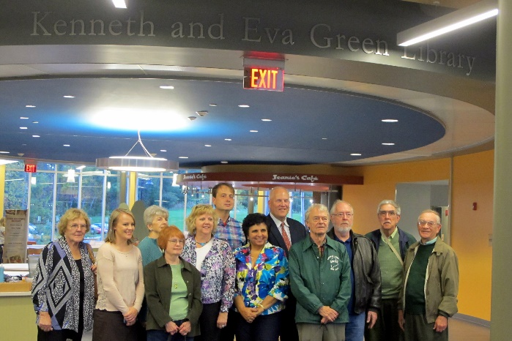
The highlight of the tour was a stop at the Kenneth and Eva Green Library in the “new” building (as the students like to call the Alfond Academic Building). The library was named in honor of the Greens as Ken’s gift enabled Thomas to start construction of the complex two years ahead of schedule. The Committee then held its October meeting in the board room above the library.
Figure 2 - Members of the Kotlas Connection and Thomas College representatives in the new Kenneth and Eva Green Library

At every step of the tour it was obvious that we were visiting state of the art facilities that are maintained in a spotless manner. Our student guide, Felicity Grant, remarked that Thomas students do their best to keep their campus clean because they’re proud of their school and the many improvements that have been made in the past few years.

We all felt that Ken Green would have been proud, too.

WANT TO KNOW MORE?
For more information on the Connection’s activities, please visit our web site at http://www.kotlas.org.

