BULLETIN FROM THE KOTLAS CONNECTION CHAIRS

Issue # 46 January 2016

SUZANNE MASSIE ADDRESSES ANNUAL MEETING

Suzanne Massie was our featured speaker at our annual meeting on November 10. She is known as a bridge builder between the Russian and American people. How appropriate a person to share her world view with us during the celebration of the 25th anniversary of our sister city connection to Kotlas, Russia. Her past history indicates she encouraged people-to-people diplomacy even during the Reagan years when relations with Russia were strained. Many of us can remember that time.

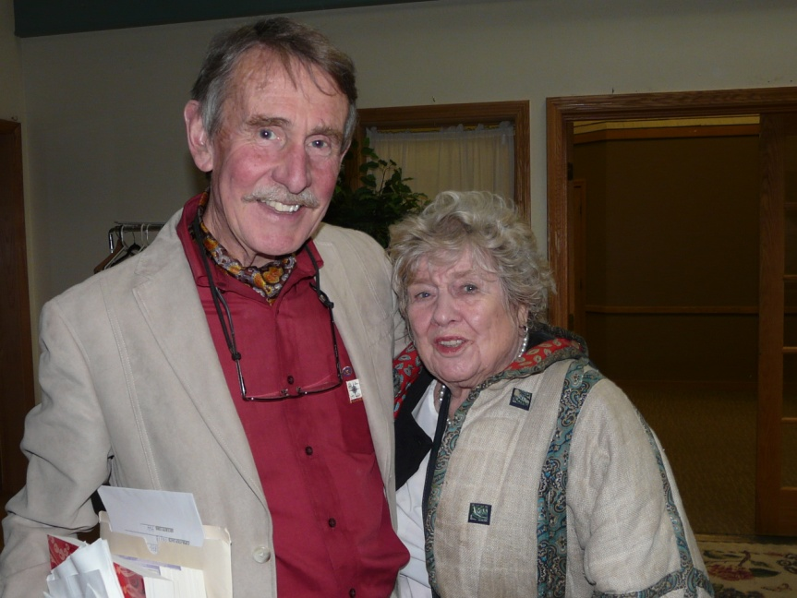
Massie now resides in Blue Hill, Maine, with her husband, Seymour Papet. She travels around the country as an expert on Russian-American relations. She is author of several books, the most recent of which is Trust But Verify, and played an important communications role between Ronald Reagan and members of the Soviet government during the final years of the Cold War. She has spearheaded many cultural exchanges over the years.

Her involvement during the Reagan years was the focus of her talk, but she also shared her observations of Putin’s Russia today. Her personal stories gave us a front seat view of the importance of the Russian Orthodox Church and its impact on current Russian events. She warned us about the negative views of American media shaping our opinions about Russia. Her view of the “benefits to humanity as a way to avoid crisis through direct person-to-person communication” is very important in these times, as our countries seem to be reentering another Cold War era. She reminded us of the important work we do to maintain friendships, knowing that no matter where we live, we share the same hopes and dreams for peace.
Peter Garrett and Suzanne Massie Photo by Greg Smith

2016 DUES

If there is a return envelope included with your bulletin, the Kotlas Connection
has not yet received your $10 membership dues for 2016.
Thanks to all who continue their support of our sister-city relationship,
now in its 26th year!

ORNAMENT SALES TOP $1,000

The Connection had a very successful Christmas season selling Russian-made ornaments. Total sales at the annual and December Connection meetings, the two holiday craft shows at Temple Academy and Waterville High School, and at Jorgensen’s Café and the Washington Street branch of Kennebec Federal Savings (KFS) came to $1,007.75. We are very appreciative to all those who supported our fund-raising efforts by purchasing ornaments and the two businesses that allowed us to display and sell the ornaments at their establishments. Sales were enhanced this year by the good weather and an abundant supply of ornaments.

We thank our friends in Russia for keeping us well supplied. This year we received a surprise bounty of ornaments from Kotlas businessman Andrei Strekalovskii, who visited Maine as a member of Kotlas Mayor Andrei Bral’nin’s delegation to celebrate the 25th anniversary of our sister-city relationship. Strekalovskii is a Kotlas City Council deputy and a small businessman. He told Connection members how impressed he was by the all-volunteer Connection activities and wanted to help support future exchanges. He has demonstrated his support with the delightful surprise of a huge box of ornaments, which arrived just in time for our December sales. We are extremely grateful to Andrei for his kind and generous contribution. Our thanks also go to Anya Egorova, daughter of our long-time friend and Waterville Committee member Zinaida Egorova. With funds provided by the Kotlas Connection, Anya devoted time to shopping in St. Petersburg for a beautiful selection of ornaments and mailing them to us.

RUSSIAN SAMPLER 2016

As Connection members start the new year, preparations for our annual Russian Sampler on Monday, March 21, 2016, are getting underway. As most of you know, Sampler, a one-day conference co-sponsored by the Connection and the Colby College Russian Program for area middle and high school students, is an opportunity to learn about Russian history and culture. Connection members, Colby College students and faculty, and community members teach a variety of sessions, which include classes on our sister city Kotlas, conversational Russian for beginners, fairy tales, church art and music, Russian schools and family life, Samantha Smith, cooking, and several craft studios to make dolls, ceramic folklore figures, and wood painting. This year we are very pleased to have dancers from the Bossov Ballet teach ballet and folk dance classes at Sampler. These classes will surely be a special treat for all the American students.

Every year a highlight for the American students is meeting and talking with visiting high school students and teachers from Kotlas, who teach sessions. This year we await the arrival of students Darya (Dasha) Slepukhina and Konstantin (Kostya) Epp with their teacher, Arina Pavlova. Our Kotlas guests will spend about a week in Maine, traveling to see the coast, Portland, Augusta, and other attractions. They will visit local schools and talk about Russia with elementary and high school students. It will be a full and busy visit for our guests.

If you would like more information about Sampler, have an idea for a session which you would lead, or want to volunteer to assist a session leader, please contact Sheila McCarthy at smccarth@colby.edu or 877-9587. We would all be grateful for your participation.

MAKSIM VAGANOV’S EXPERIENCE AT THOMAS COLLEGE

Going to a college in America has been my dream for a long time, ever since I went to a high school here in Maine as an exchange student in 2008-2009. The only way for this to happen was if I received a scholarship, which I finally did, and with financial help from Mark Fisher, for which I am very grateful, my dream came true less than half a year ago.

The experience of going to an educational institution in America itself was not new to me for the aforementioned reason. What was different is the size of the school. I go to Thomas College, where I am getting my Masters of Business Administration. It is an accelerated program and it takes only one year to finish, which is different, as there is no such thing in Russia. So, when I talk about the size of the school, I mean that in Russia I went to one of the largest universities in Europe with almost 50,000 enrolled students each year. Having that in mind, Thomas is only a little bit over a 1,200. What that means for me as a student is that the overall environment is very friendly and family-like. You can easily contact any of the school’s officials, consult them, and solve any problems that you have, which was obviously nearly impossible for me in my university back home. I always thought, though, that the learning process would also be different. As it turned out, however, it really is not that different. I mean, most of management is based on American studies and theories, so there is really not much difference in study materials, learning techniques and so forth, if compared to education in Russia.

The only striking difference between universities in Russia and the United States is really the environment, and by that I mean life on a campus. Sadly, I do not live on campus and cannot experience that life first-hand. However, by looking around and receiving numerous e-mails about the life on campus I get a glimpse of what it would feel like. Again, I am very grateful for this opportunity and this is definitely one of the life-changing experiences of my life.

ELECTION OF OFFICERS AT ANNUAL MEETING

At the annual meeting on November 10, the following were elected to the Executive Committee of the Kotlas-Waterville Area Sister City Connection: Ellen Corey as Co-chair. Carl Daiker was reelected for another term as Treasurer. Continuing in their two-year terms are Mary Coombs as Co-chair, and Sheila McCarthy as Secretary. Reelected as at-large members of the Executive Committee for one-year terms are: Joe Couture, John Engle, Mark Fisher, Herb Foster, Phil Gonyar, Marilyn Hall, Pauline Mayhew, and Martha Patterson.

